**Utility Bill Pay – Developer 1**

Implementation Screenshots:

1. Login - User should be able to login to the application with employee ID and OTP

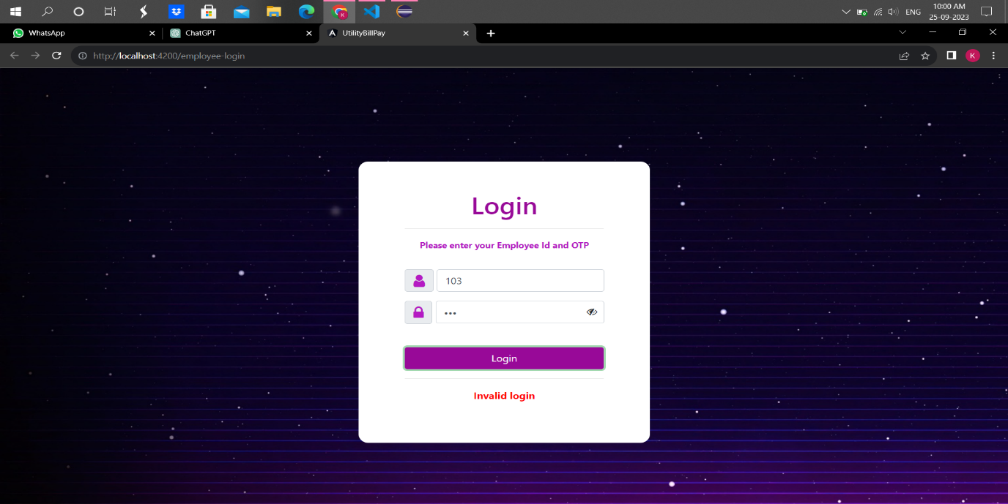

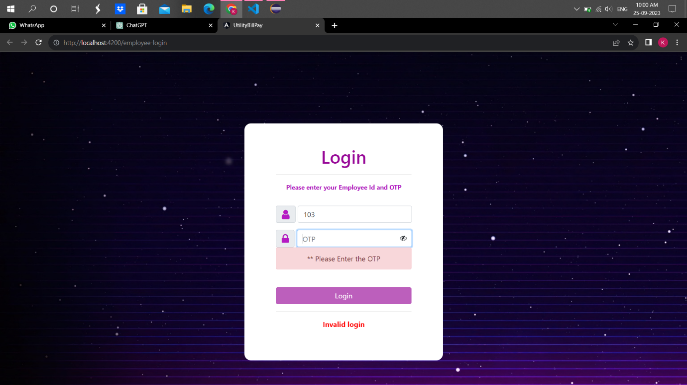

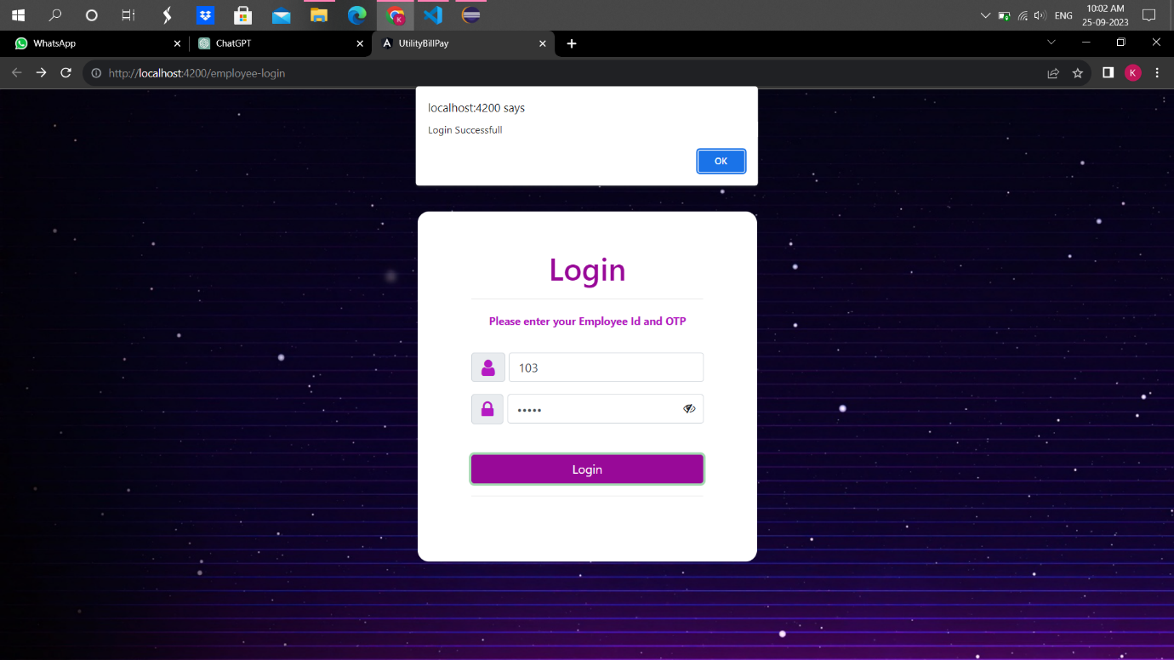

2) Customer data management

a. Manual Customer Data Entry

- Users should be able to manually add customer information, including Name, Customer ID, Unit Consumption, Duration of bill by month/date range, Bill due date, Email, and Telephone number.

- The application should validate and store this data securely.

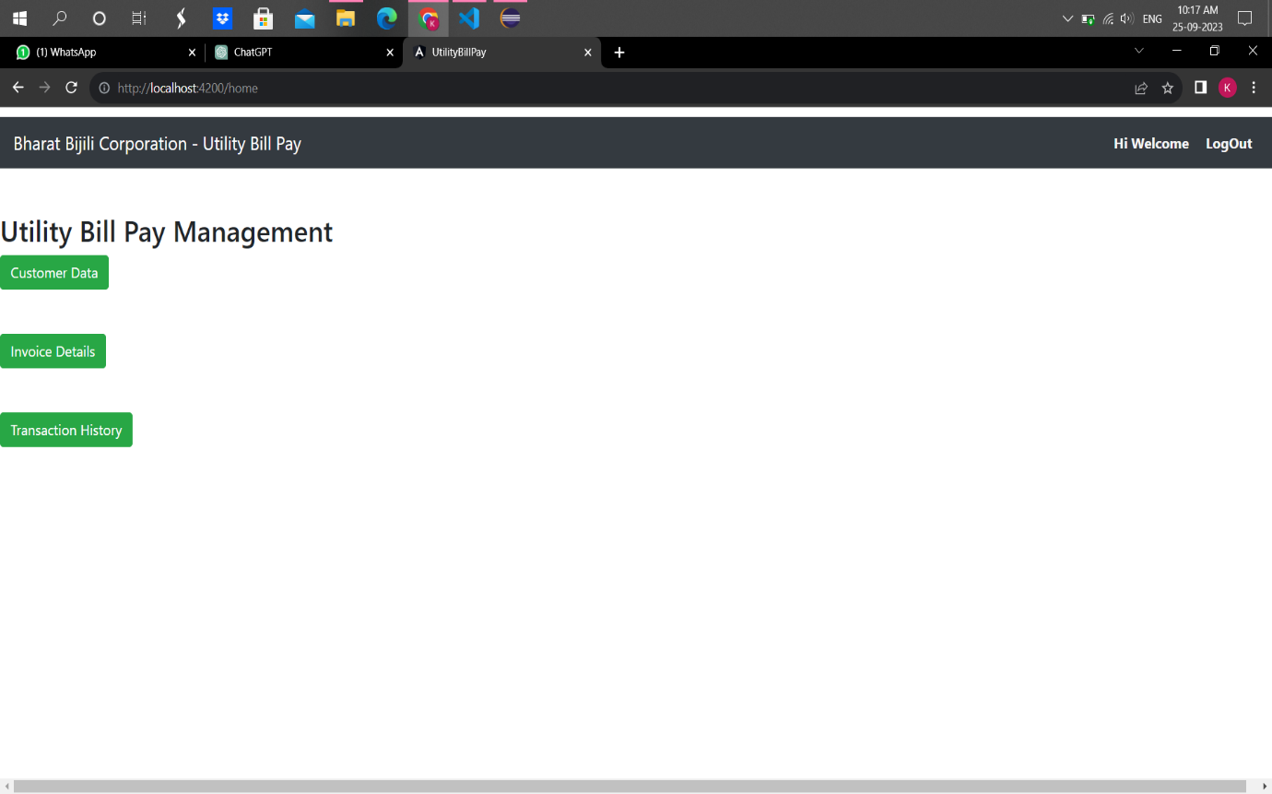

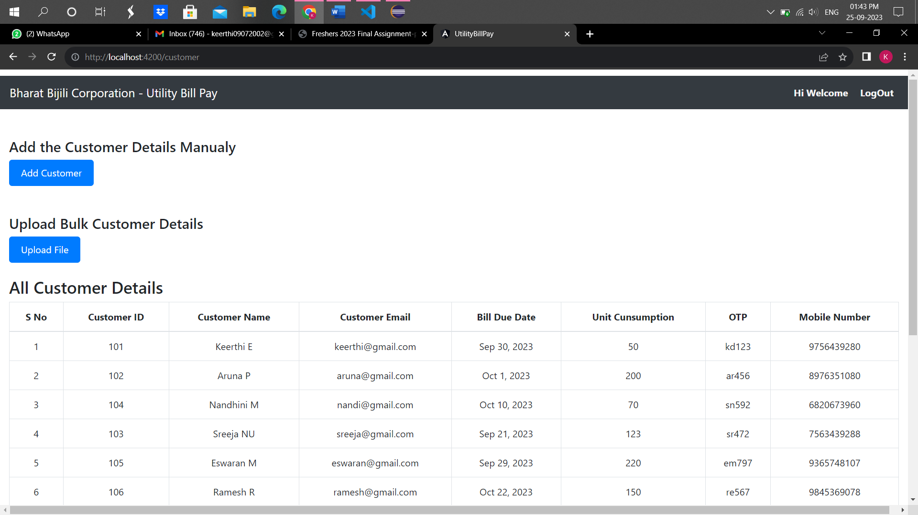

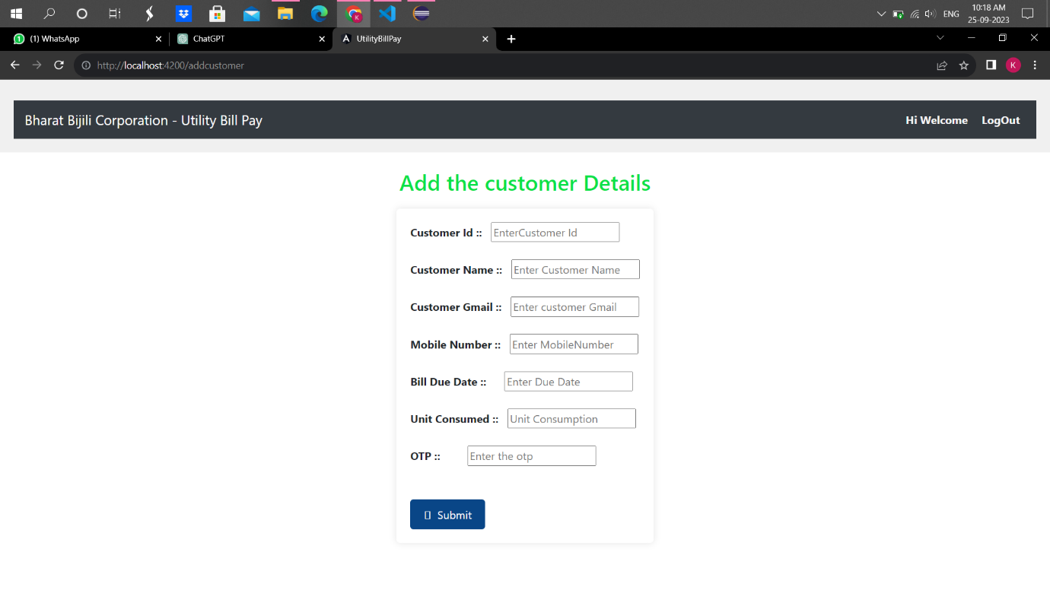

b. Bulk Customer Data Upload

- Users should have the option to bulk upload a comma CSV file containing customer data with fields (Name, Customer ID, Unit Consumed, Bill due date, Email, Telephone).

- The application should validate the uploaded data, handle any errors, and store valid records.

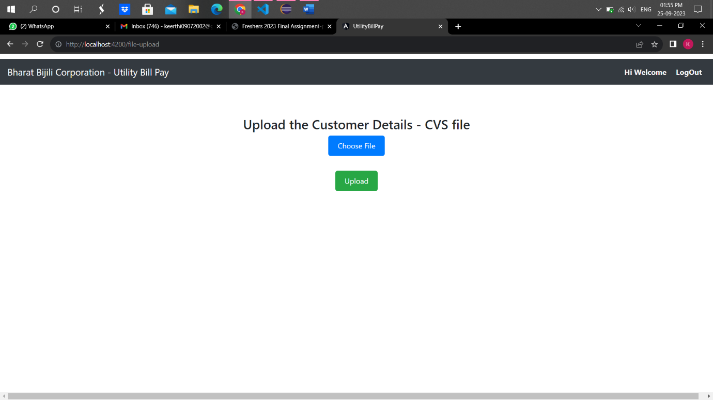

1. Invoice Generation a. Invoice Generation

- The application should automatically generate invoices based on the customer data and predefined billing rules.

1) Billing as per the units consumed by the user 1Kw of energy consumed is for Rs. 41.50

2) Discount of 5% to the user if the payment is made before the due date

3) Discount to the user if they make payment online by 5% - Invoices must include customer details, the amount due, and the due date

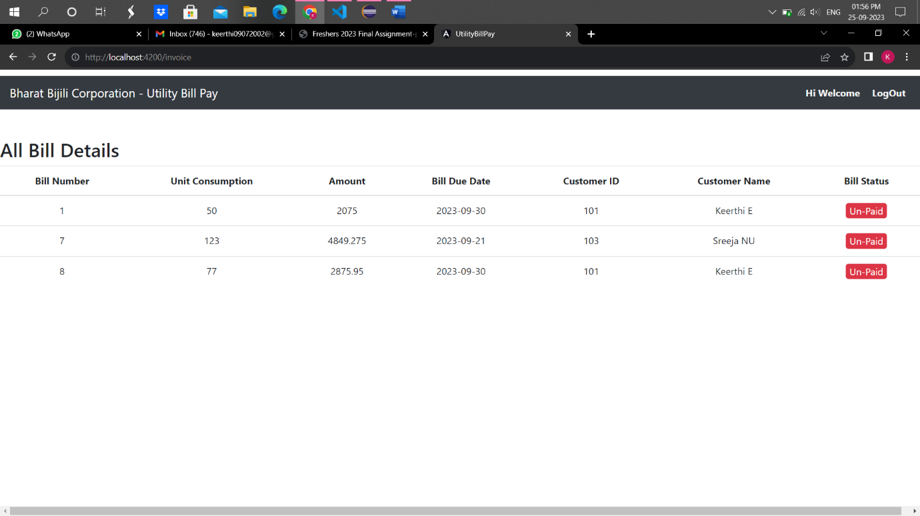

4) Payment Transaction Tracking

a. Transaction History

- The application should maintain a transaction history for each customer, showing all payment transactions, including the date, amount, and payment method.

